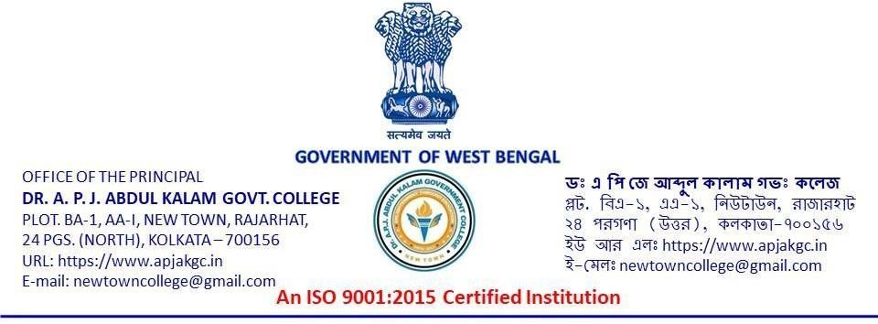
Notice No: Kanyashree/APJGC/25/8 Date: 12.12.2025

NOTICE

All the 1st year Students, 2025-2026 are requested to assemble in Room No. 213 (14) in our College for a meeting regarding the Kanyasree K2 Form. On 16/12/2025 at 01:15 P.M. onwards
****Your presence is mandatory.

________________S/d__________________
Convenor, Kanyashree Committee
Dr. A.P.J. Abdu;l Kalam Government College
Newtown, Rajarhat, Kolkata-700156
______________S/d__________________
Officer-in-Charge
Dr. A. P. J. Abdul Kalam Government College,
New Town, Rajarhat, Kolkata-700156

