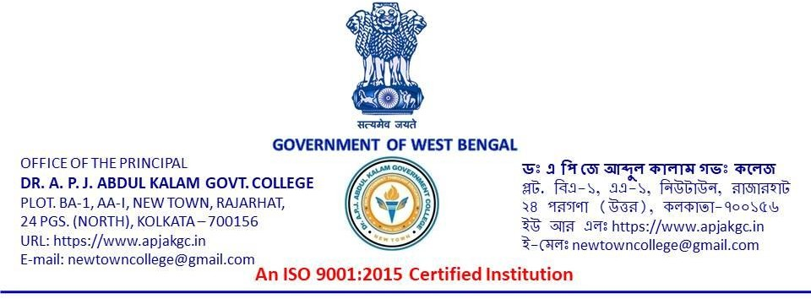

Notice No: 1408 Date: 24.12.2025

NOTICE

We are going to organize Photography Competition aimed at celebrating Students’ Week on 2nd January 2026 (Friday). All current students of our college can unfold their photographic narrative and aesthetic vision with the audience. Participants eager to share their photo/s (maximum 3), have to send it to photos.dr.apj@gmail.com by 28.12.2025 (Sunday). Students should have to follow strictly the guidelines for the competition.

-Sd-
Mousumi Chakravorti

Officer-in-Charge
Dr. A. P. J. Abdul Kalam Government College
New town, Rajarhat, Kolkata – 700156

